Themenblock 11: POLITICS & LEGAL ISSUES
CATEGORY A: CONTRASTING IMAGES
TASK SET A1: Digital Activism vs. Street Protest

PART 1 — Individual Long Turn
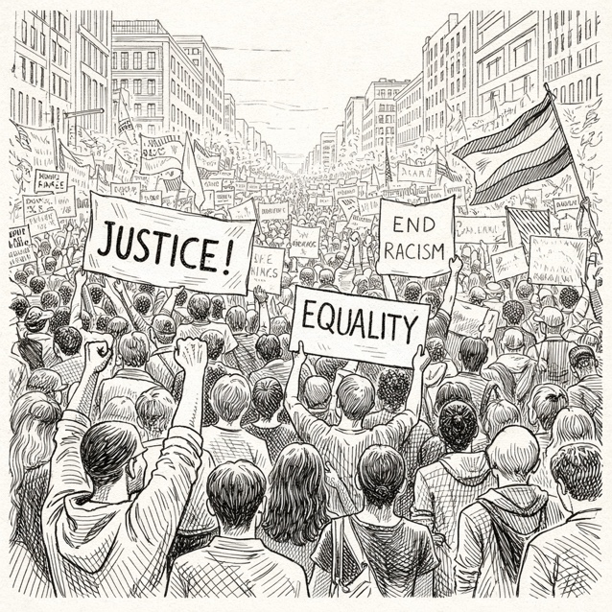
Task:
Give a five-minute talk on digital activism vs. street protest in which you
- describe, compare and contrast the two illustrations above.
- analyze the advantages and disadvantages of digital activism versus physical protests
- discuss whether online engagement can create real political change.

PART 2 — Paired Activity
Task: Your school is creating a "Young Citizens" awareness campaign to encourage students to become more politically engaged. You and your partner are on the campaign design team.
Discuss the following content ideas and agree on three main messages to include:
- The importance of voting and how to register
- Ways to contact and influence local politicians
- How to organize or join peaceful protests effectively
- Using social media for political awareness and activism
- Volunteering for causes and community organizations

TASK SET A2: Democracy Then and Now

PART 1 — Individual Long Turn
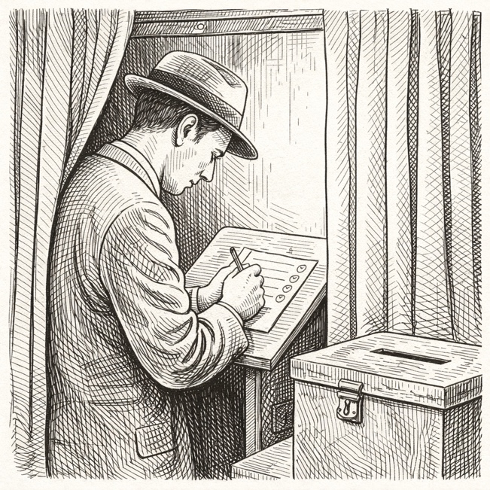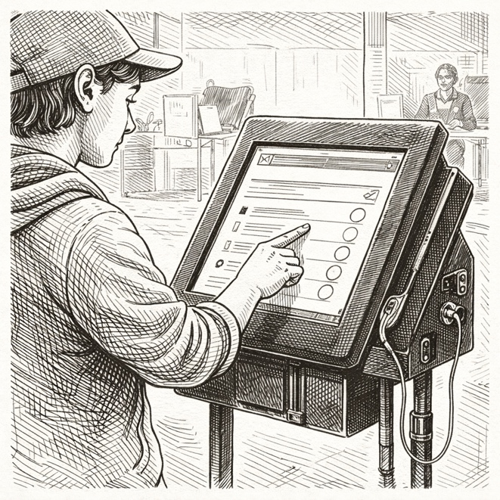
Task:
Give a five-minute talk on democracy then and now in which you
- describe, compare and contrast the two pictures above.
- analyze how methods of democratic participation have evolved over time.
- discuss whether digital democracy strengthens or threatens democratic values and participation.

PART 2 — Paired Activity
Task: Your school is conducting research on the future of voting and democratic participation for a social studies project. Discuss these research questions and agree on three to prioritize:
- Does online voting increase or decrease voter turnout among young people?
- What security risks does digital voting create, and how can they be addressed?
- Should voting be mandatory, and would this strengthen democracy?
- How does social media influence political opinions and voting decisions?
- What barriers prevent young people from participating in elections?

TASK SET A3: Power From Above vs. Power From Below

PART 1 — Individual Long Turn
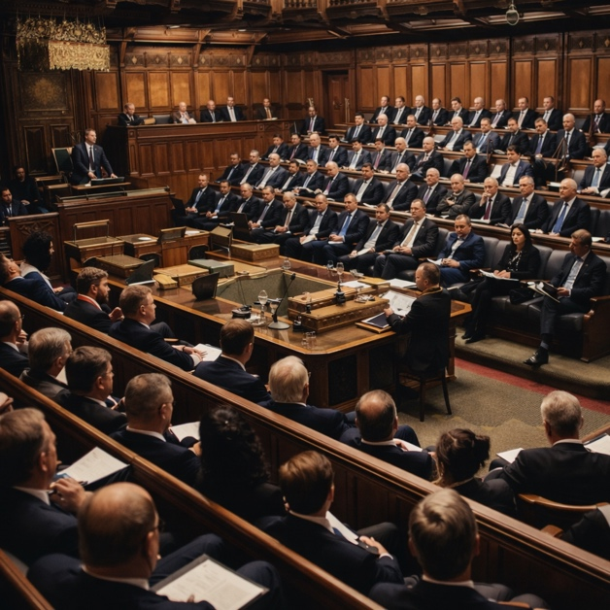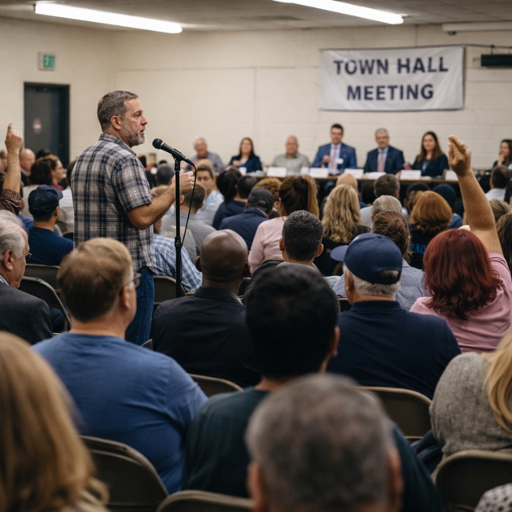
Task:
Give a five-minute talk on power from above vs. power from below in which you
- describe, compare and contrast the two pictures above.
- analyze the advantages and disadvantages of representative democracy versus participatory/direct democracy.
- comment on which approach you believe better serves citizens' interests and why.

PART 2 — Paired Activity
Task: Your school is organizing student council elections and wants to make them more democratic and engaging. You and your partner are on the election planning committee. Discuss and agree on three organizational aspects:
- How candidates should present their platforms (debates, videos, posters, etc.)
- Whether voting should be online, paper-based, or both
- How to encourage more students to vote and participate
- Rules for fair campaigning and preventing misinformation
- How to ensure the election results are transparent and trusted

CATEGORY B: QUOTES

TASK SET B1: Justice and Responsibility

PART 1 — Individual Long Turn
Quote 1:
"Injustice anywhere is a threat to justice everywhere."
— Martin Luther King Jr., Civil Rights Leader
Quote 2:
"If you are neutral in situations of injustice, you have chosen the side of the oppressor."
— Desmond Tutu, Archbishop and Nobel Peace Laureate
Task:
Give a five-minute talk on justice and responsibility in which you
- analyze the two quotes and their relevance to democratic citizenship
- discuss why young people may be disengaged from politics.
- evaluate the personal costs and rewards of standing up for justice.

PART 2 — Paired Activity
Task: You have been granted a meeting with your local mayor to discuss youth concerns about social justice issues in your community. Discuss these topics and agree on three to focus on:
- Discrimination and equal treatment in schools and workplaces
- Access to affordable housing for young people
- Police-community relations and public safety
- Environmental justice and pollution in disadvantaged areas
- Support for marginalized groups and minorities

TASK SET B2: Democracy as Action

PART 1 — Individual Long Turn
Quote 1:
"The ballot is stronger than the bullet."
— Abraham Lincoln, 16th U.S. President
Quote 2:
"Democracy is not a spectator sport."
— Lotte Scharfman, League of Women Voters Activist
Task:
Give a five-minute talk on democracy as action in which you
- analyze and compare the two quotes above
- discuss the challenges to democratic participation that young people face today.
- outline specific ways that young people can actively participate in democracy beyond voting.

PART 2 — Paired Activity
Task: Your school wants to launch civic engagement initiatives to help students become more active citizens. Discuss the options below and agree on three initiatives to launch:
- A voter registration drive and "how to vote" information session
- A "shadow your local politician" work experience program
- Regular debates on current political issues in school
- A student-run newspaper or podcast covering local politics
- Partnerships with local NGOs for volunteer opportunities

CATEGORY C: ALTERNATIVE PROMPTS

TASK SET C1: The Youth Vote Gap

PART 1 — Individual Long Turn
Text Extract:
In the 2024 European Parliament elections, youth voter turnout declined by 6 percentage points among 15-24 year-olds compared to 2019's record-breaking surge. While 64% of young Europeans said they intended to vote in pre-election surveys, only 46% of first-time voters actually cast ballots. The main barrier? Not cynicism about politics — just 14% of young non-voters distrust politicians — but a simple lack of interest: 28% said they weren't engaged enough to vote. Meanwhile, four EU countries (Austria, Belgium, Germany, and Malta) now allow 16-year-olds to vote in European elections, though results have been mixed.
Sources: Eurobarometer Post-Electoral Survey 2024; EU-Council of Europe Youth Partnership Report 2024; FEPS Analysis
Task:
Give a five-minute talk on the youth vote gap in which you
- analyze the statistics presented and explain what they reveal about youth political engagement in Europe.
- discuss reasons why young people may be disengaged from politics and whether this is a serious problem for democracy.
- outline strategies that could increase youth political participation.

PART 2 — Paired Activity
Task: Your school is hosting a debate on the motion: "The voting age should be lowered to 16 nationwide." Take opposing positions (one pro-lowering, one anti-lowering) and debate the following aspects:
- Whether 16-year-olds are mature enough to make informed voting decisions
- The impact of lowering the voting age on youth political engagement
- Whether voting at 16 would increase or decrease overall voter turnout
- The consistency argument: if you can work and pay taxes at 16, should you vote?
- Evidence from countries that have already lowered the voting age

TASK SET C2: Who Represents Young People?

PART 1 — Individual Long Turn
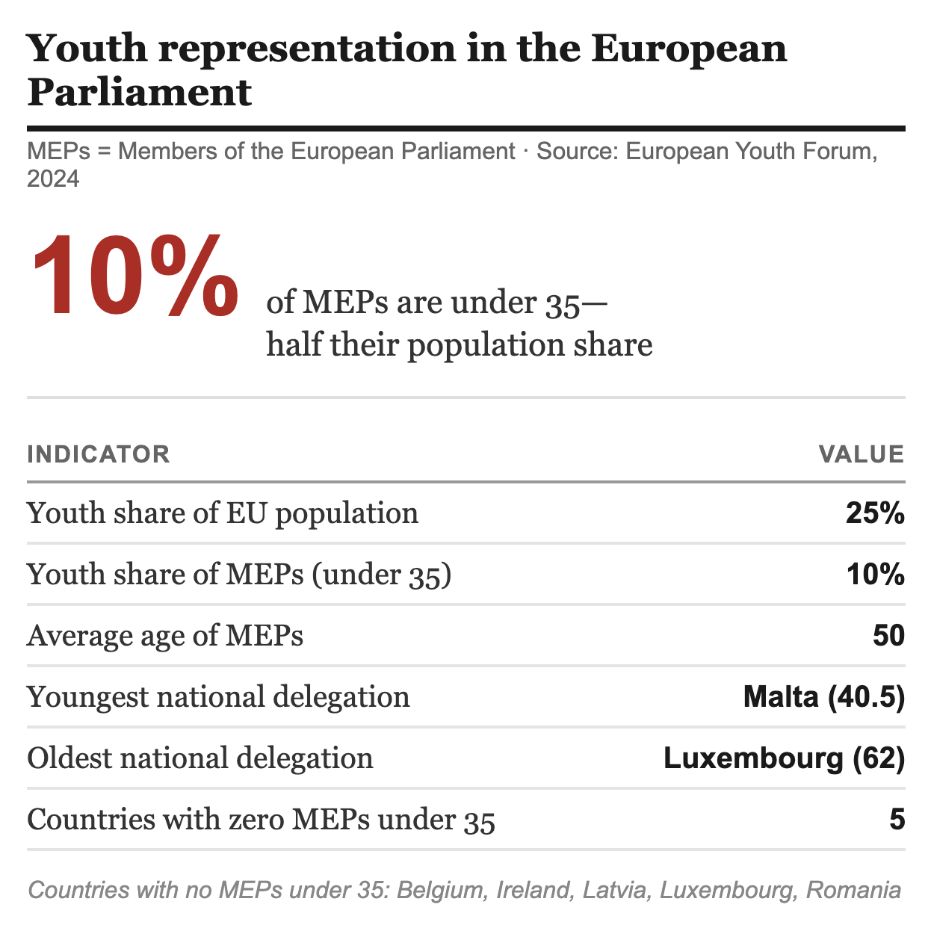
Task:
Give a five-minute talk on who represents young people? in which you
- analyze the data and what it reveals about youth representation in politics.
- discuss whether the age of political representatives matters for the quality of democratic representation.
- evaluate possible solutions for improving youth representation in politics.

PART 2 — Paired Activity
Task: You are working with a youth policy advisor to propose reforms for better youth representation in politics. Discuss the following reform ideas and agree on three priorities to recommend:
- Mandatory youth quotas on party candidate lists
- Lowering the minimum age to stand for election
- Creating official youth advisory councils at all levels of government
- Reserved seats in parliament for representatives under 30
- Funding programs to train young people for political careers

